# EDUCATION

## Higher Secondary Education (12th)

### Kendriya Vidyalaya

*07/2016 - 08/2017*, *Completed with 85% marks*

## Bachelor of Physiotherapy (BPT)

### Manav Rachna International Institute of Research & Studies

*08/2017 - 08/2021*, *Completed with 75%*

# CORE COMPETENCES

Summarising Medical Records For Underwriter In Insurance.

Eﬀectively Conduct Critical Assessments & Preventive Care Expert.

Exposure to MVA Cases, Exposure To Prepare A Judgement Of A File.

**WORK EXPERIENCE**

Excellent Patient & Family Communicator.

Adapt in Handling Equipment & Instruments.

## Intern

### ESIC Medical College & Hospital

*07/2021 - 02/2022*, *Noida, India*

*Achievements/Tasks*

Maintained Patient records & documentary h/o in details.

Worked in the department of Orthopedics, Cardiology, Paediatrics , Neurology, Oncology, ICU, Mucormycosis, COVID- 19 ICU.

Examined 10+ patients daily, formulated accurate diagnosis & best course of treatment.

## Senior Associate

### Innodata India Pvt. Ltd.

*03/2022 - 06/2023*, *Noida, UP*

*Achievements/Tasks*

Medical Summarization and transcription.

## Senior Process Executive-Voice

### Cognizant Technology Solutions

*06/2023 - Present*, *Gurugram*

*Cognizant Digital Business Ops*

Medical Scribing, Heath Claims and TPA

# SEMINARS ATTENDED

#### SEMINARS ATTENDED

An advanced Neuro Rehabilitation dimension organized by Department of Physiotherapy FAHS, MRIIRS, 2019.

#### Necessity of Physical activity

Cardiovascular Risk in COVID-19 patients organized by Department of Physiotherapy FAHS, MRIIRS, 2020.

# ORGANIZATIONS

#### Manav Rachna O.P.D & Neuro O.P.D, Faridabad (07/2019 - 09/2019)

Park Hospital, Faridabad (11/2019 - 01/2020)

***Internship***

#### Surya Ortho Clinic, Faridabad (01/2020 - 03/2020)

***Internship***

#### ESIC Medical College & Hospital, Faridabad (07/2021 - 02/2022)

***Internship***

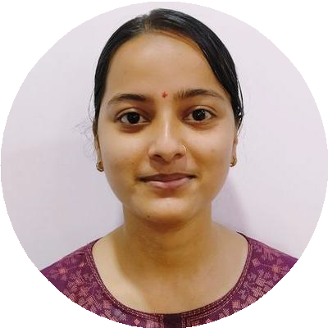

Dr. Aparna Pandey

Senior Process Executive

*Experienced medical records reviewer/summarizer. Responsible for reading available medical records and writing a summary of these records. Identifying the claimant's past medical history and treatment rendered.*

[aparnapandey118@gmail.com](mailto:aparnapandey118@gmail.com)

8368112646

Faridabad, India

[linkedin.com/in/aparna-pandey-589a311b8](https://linkedin.com/in/aparna-pandey-589a311b8)

**DECLARATION**

It is certiﬁed that the above information is true to the best of my knowledge. I promise to satisfy my superiors to the best of my ability